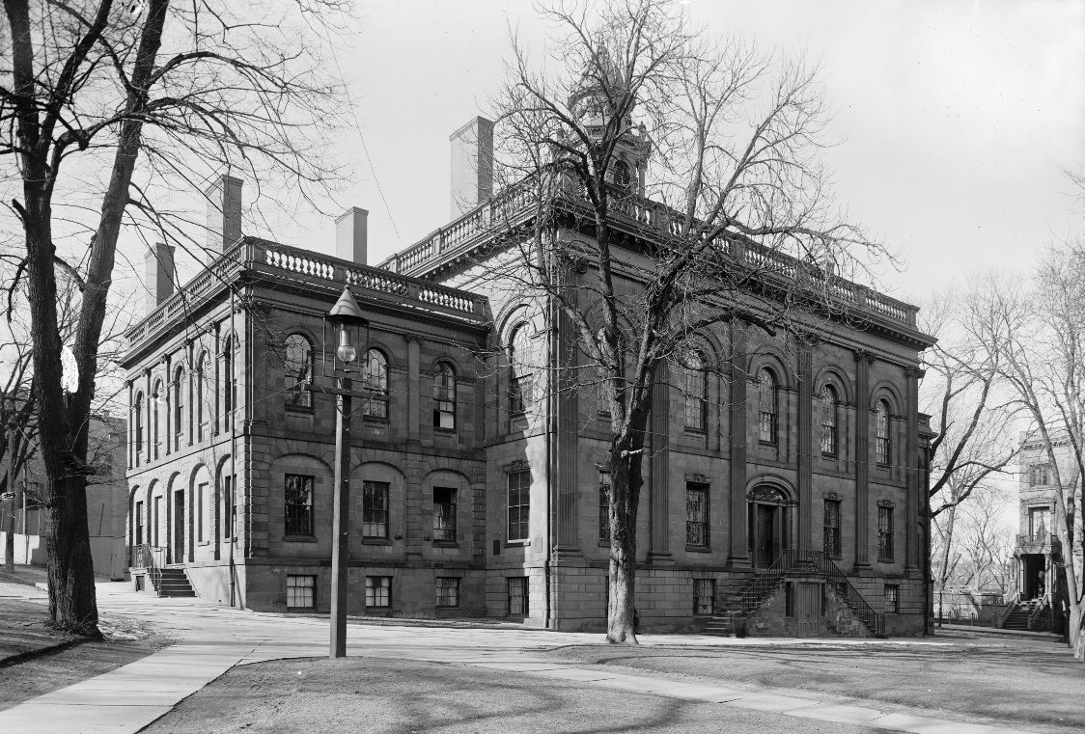

MINIMUM CAPACITY :-

The Minumum intake capacity

of students is between 150-350

children

LIBRARY :-

The Libarary is Available.

CANTEEN:-

The Canteen Facility is Available.

BOARDING :-

No availablility of boarding.

SPORTS :-

There are different categories

sports available.

Girls Volleyball

Boys Volleyball

Football

|  |  |  |
| --- | --- | --- |
| THE ALBANY ACADEMY  ALBANY - SCHOOL |  |  |
|  |  |  |
| School Detail :- The Albany Academies coordinate single-sex and coeducational learning environments to develop diligent students of high character who become curious, critical thinkers.  In 2013 and 2014 we celebrated the Bicentennial of both schools and ushered in our third century of excellence in education. It was a time to tout our achievements, honor our first 200 years of academic, artistic and athletic distinctions and express our gratitude to those that helped get us here.    The Albany Academy for Girls and The Albany Academy archives hold many documents, paintings, and artifacts dating from the earliest years of the two Academies and the full span of two centuries. |  |
|

